Week in Review, Issue 8 - December 21-28
Alex Shvartsman

HAPPY NEW YEAR!
Another year is almost at an end. For Magic as a mind sport, this year has been the best yet. Prize support at Pro Tours has been significantly increased, the Masters Series circuit has been established, and the Standard format seems to be combo-free for the first time in ages once Invasion replaced Urza block.
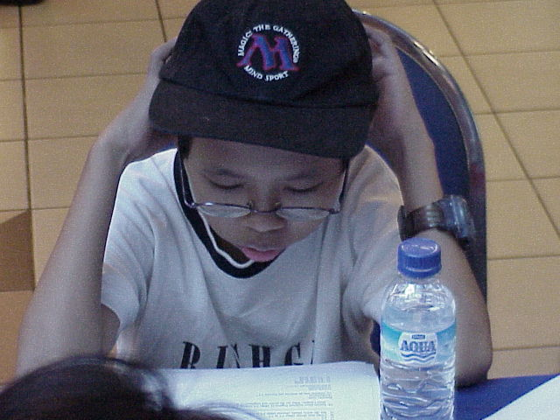
Next year is already full of promise. Based on last week's announcement, all National championships will be offering considerable cash prize support in 2001. The number of Grand Prix tournaments has been increased, and a variety of other good things are in the works.
There are plenty of interesting things to watch out for next year. Now that Hovi, Finkel and Budde all have a pair of Pro Tour wins, will any other player join this elite group, or will one of them break away at three wins? Furthermore, will any player dethrone Budde's record of three Grand Prix wins? Will any player manage two Masters Series wins? Will Jon Finkel win a Masters tournament to complete his resume? Can 2001 possibly be any better than the year 2000 has been? I guess we'll just have to see.
Happy New Year everyone.

TEXAS/LOUISIANA INVITATIONAL
In what is becoming an annual tradition, Event Horizons - tournament organizer that runs PTQs in Texas and Louisiana is going to be holding a 16 person Invitational tournament in January.
They are still in the process of selecting participants, but the formats have been announced - and boy are they wacky! How about a draft format where you sit down with pen and paper and name any card from Invasion that has not already been named by someone else in order to draft it? Or an Invasion-block Constructed format where you may design your own card and add 4 copies of it to your deck (organizers will first check to make sure the card is not unfair).
I will write more about this event in January, but check out the announced formats in the meanwhile.

100 HOURS OF MAGIC
What better way to celebrate Christmas than by playing Magic until you drop?
Amigo - the German Magic distributor - hosted a series of Magic events this week that ran for 100 hours non-stop! Among them, several Pro Tour Qualifiers, artist signings, a number of smaller tournaments and pick-up drafts. Other games, such as "The Great Dalmuti" were also scheduled.
Special thanks to the readers who let me know about this cool event.

PRO TOUR PLAYER OF THE YEAR RACE UPDATE

This update will discuss the implications of PT Chicago and the effect of the next Grand Prix season (including Grand Prix: New Orleans, Amsterdam, and Hiroshima) on the current race. Post-Chicago standings are as follows:
1 Kai Budde 40
2 Scott Johns 35
3 Michael Turian 29
4 Gary Wise 28
5 Kamiel Cornellissen 28
6 Robert Dougherty 24
7 Mike Pustilnik 21
8 Noah Boeken 20
9 Ryan Fuller 18
10 Nicolai Herzog 18
Only two Pro Tours into the season, it is not surprising that the winning team of PTNY and the top 2 finishers of PT Chicago are all in the top 5.
Budde broke into the scene with an amazing season in 1999, culminating in his winning the World Championship and earning the Player of the Year title. Last season however has been a giant slump for the German Juggernaut. He has had a slow year on the Pro Tour and a streak of very bad luck in Grand Prix.
Budde is back in a big way now. He broke the streak of poor luck with a Top 4 finish at GP Florence and followed it up by a 32 point Pro Tour win. This gives Budde a comfortable lead in the race. He is likely to remain ahead of the competition entering into PT-LA.
Johns got a solid lead over his teammates Turian and Wise during the last sub-season. All three of them had a solid but unspectacular showing in Chicago, solidifying their positions in the race. It is likely that Wise (who will be attending both New Orleans and Amsterdam) is going to overcome Turian by several points, but it would take at least a pair of Top 8 finishes for him to steal the #2 spot away from Johns, who is likely to attend New Orleans as well.
Cornellissen is currently tied with Wise for fourth place, thanks to his PT Chicago performance. It is unclear whether he will keep the position in this sub-season. It would almost certainly require him to attend Amsterdam. Dougherty has a decent shot at overcoming Cornellisen as well, if he travels to those two events as expected.
Pustilnik, Boeken and Fuller have all benefited greatly from the Grand Prix circuit this season. Boeken is likely to attend Amsterdam only, but it may be difficult for him and Herzog to keep up with Fuller and Pustilnik, both of whom are likely to attend all three of the Grand Prix scheduled for this sub-season. All of them are likely to pick up at least some points in the process.
How are the last season's top finishers faring right now? Player of the Year Bob Maher is in 29th place with 13 points, 8 of which he earned in Chicago. Finkel is ahead of him in 18th place with 15 points. He is tied with Darwin Kastle, also at 20 points. I am currently 37th, at 11 points. Ben Rubin is somewhere in the low 60s having earned 8 points so far.

YOUR MANA'S WORTH: Breaking Saproling Burst
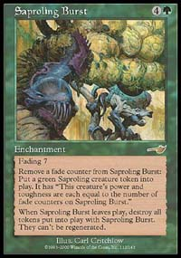
There has recently been a lot of debate among the high level judges as to whether it is possible to "break" Saproling Burst by abusing the timing rules. It has been suggested that one may put removing a pair of tokens on the stack, then Disenchant the Burst in response. Since the Burst is no longer there when Saprolings come into play, they would check for the "last known characteristics" of the Burst and remain in play as 5/5 creatures.
Leading rules gurus Dan Gray and Paul Barclay have disagreed with this interpretation and were quick to point out that the tokens will, indeed, be destroyed. Paul Barclay has offered the following explanation:
The "loophole" recently discussed involving Saproling Burst and Disenchant doesn't actually exist. If you Disenchant the Burst in response to activating it's "make a creature" ability, the token will come into play, look around, fail to find any Fading counters on the Saproling burst that created it (because it's not in play), realise that it's 0/0 and die a fairly humane and painless death.
The reason that the burst token ends up as a 0/0, not as a 6/6 is because continuous effects don't use last known information (LKI) - they just use the current state of the game. This is because all sorts of weird things would happen otherwise (Crusade would "remember" that a now blue creature was white at one point, and still give it +1/+1, which is obviously silly).
The number of counters on a permanent, like any other information _is_ part of the Last Known Information about that permanent. The best example of this is Tangle Wire - even if you Disenchant it while its ability is on the Stack, you'll still have to tap the same number of permanents.

BEST OF THE NET
In his latest article titled Mind Sports, Star City columnist Aaron Forsythe examines the differences - and a few surprising similarities - between Magic and a variety of other games - from sporting events to Poker to other mind sports such as Chess and Go. This is an incredibly well-researched article that I strongly recommend.
A long-awaited PT Chicago report by Brian Kibler has finally appeared on The Dojo earlier this week.

PLAY OF THE WEEK
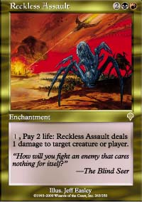
Reckless Assault can be an excellent creature control card - able to take out Tappers and other annoying little creatures - but you can't get too carried away with it at a steep cost of 2 life per point of damage.
My friends Ray Lopez and Chris Kneght were playing a round of sealed deck. Ray had a pair of Armadillo Cloaks and worked some magic over his mana to make Reckless Assault fit into the same deck with them. His explanation? "If these two cards ever get into play at the same time, I can really get going!" And he did, too - reclaiming some life spent via Assault by attacking with a 5/5 trampling spirit linked Darigaaz's Attendant. Chris soon dealt with the enchanted creature, but it was quite amusing anyway.
Okay, this isn't an amazing Pro Tour play, but with no title events for several weeks I take what I can get.

BAD PLAY OF THE WEEK
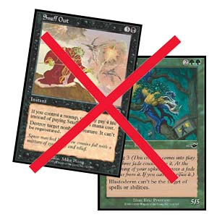
This little episode took place during the draft portion of the Turkish National Championships.
One of the players paid an alternative casting cost of Snuff Out, while controlling no Swamps, targeting a Blastoderm. His opponent did not seem to find anything wrong with this, and placed Blastoderm into the graveyard! Fortunately a judge noticed this right away and corrected the problems.
Thanks to Cem Onur Bas for reporting this story.
Got a play of the week, or any other interesting bit of information? Please e-mail me at ashv@concentric.net.

